**COLLABORATIVE PROJECT WITH INTEL**

**PROJECT TITLE : ROAD OBJECT DETECTION WITH DEEP LEARNING**

**TEAM NAME :** **TEAM MITTSUI EXPLORERS**

**Team Mentor : Dr T V RAJINI KANTH, Professor & Head,**

**Department of CSE-AI&ML**

[**rajinitv@gmail.com**](mailto:rajinitv@gmail.com)**,**

[**rajinikanthtv@sreenidhi.edu.in**](mailto:rajinikanthtv@sreenidhi.edu.in)

**Ph. No: 9849414375**

**Team Members : T. V. S. Aneesh** Roll no: 20311A0503 CSE Team lead

**P. Krishna Tejaswini** Roll no: 20311A0532 CSE Team member

**Maliha** Roll no: 20311A0489 ECE Team member

**Institute Name** **:** **Sreenidhi Institute of Science and Technology**

**Yamnam Pet, Ghatkesar**

**Hyderabad - 501301**

**Date of su bmission :** **15 -07- 2023**

**ABSTRACT:** Deep learning field has progressed the vision-based surround perception and has become the most trending area in the field of Intelligent Transportation System (ITS). Many deep learning-based algorithms using two-dimensional images have become an essential tool for autonomous vehicles with object detection, tracking, and segmentation for road target detection, primarily including pedestrians, vehicles, traffic lights, and traffic signs.

Autonomous vehicles rely heavily on visual data to classify and generalize target objects which can satisfy pedestrians’ and other vehicles’ safety requirements in their environment.

 This project aims to provide a detailed and systematic comparative analysis of five independent mainstream deep learning-based algorithms for road object detection, Helmet-no helmet detection, triple riding namely the **DNN (Deep Neural Network), Mask R-CNN, SSD, RetinaNet, and YOLOv3** on a local made road scene dataset and a publicly available dataset.

***Keywords: Intelligent Transportation System (ITS), Deep learning, Two-dimensional images, Target detection, Object Detection***

**INTRODUCTION**

Object detection has revolutionized the field of computer vision, enabling machines to “see” and comprehend visual data. It involves the identification and localization of objects within images or videos. Object detection plays a crucial role in numerous practical applications across various industries, such as autonomous vehicles, surveillance systems, medical imaging, robotics, and augmented reality [Ref. 1]. This project titled “Road Object Detection” program helps in identifying objects on Road both moving and stand-alone objects. It helps traffic authorities to identify traffic sign violation driving rule violation which helps pedestrian crossings and reduce road accidents. Gives learning pad to explore about AI & ML importance across various industrial sectors and makes path to develop various Object Detection tools to serve the society and Police Department.

**MOTIVATION**

The motivation for studying road object detection is to improve the performance and feasibility of deep learning-based algorithms for object detection under practical constraints. Some of the challenges that road object detection faces include:

* The variability of road environments, such as weather conditions, lighting conditions, occlusions, and camera angles [Ref.7, 8].
* The trade-off between speed and accuracy, as autonomous vehicles require real-time detection with high precision13.
* The model size and energy efficiency, as autonomous vehicles have limited computational resources and power consumption The Deep Learning models help developers to improve the technical understanding and implementation of AI&ML algorithms in Python.

By studying road object detection, researchers can develop new methods and techniques to overcome these challenges and enhance the performance of vision-based surround perception for autonomous vehicles.

The Intel Industrial Training initiative Unnati Program helps the students in getting the flavour of Industrial View of the work planning, interaction and guidance of Intel Team and friendly competing with other college students.

**DATA SOURCES**

Downloaded and analysed the Indian Driving dataset IDD Lite dataset from [IDD (iiit.ac.in)](https://idd.insaan.iiit.ac.in/dataset/download/) and studied on various existing models.

We have taken a video with Mobile Camera on Hyderabad Road which has various objects People, Car, Truck, Motor Cycle etc. It has more than 100 frames.

Developed code to take the input as video and generates output video with object detection labels and create frames too.

Developed a program to take picture as input and identifies it as triple riding on Motor Cycle or not.

Developed programs to identify helmet and no helmet ride on motorcycle.

**PYTHON LIBRARIES USED IN THE PROGRAMS**

**CV2 or CV:** OPEN CV Python library of Python bindings designed to solve computer vision problems. **OpenCV** is a huge open-source library for computer vision, machine learning, and image processing.

**Numpy:** NumPy is a library for the Python programming language, adding support for large, multi-dimensional arrays and matrices, along with a large collection of high-level mathematical functions to operate on these arrays.

**Argparse:** To pass the arguments to the program

**Image AI:** It is a python library built to empower developers to build applications and systems with self-contained Deep Learning and Computer Vision capabilities using simple and few lines of code.

**Image Detection:** This technology is capable of identifying objects that exist in images and videos and tracking them. Object Recognition also known as Object Detection, has various applications like face recognition, vehicle recognition, pedestrian counting, self-driving vehicles, security systems, and a lot more.

**OS:** The **OS module in Python** provides functions for interacting with the operating system.

**Keras and Tensor flow:** Keras is a neural network Application Programming Interface (API) for Python developed by Google that is tightly integrated with Tensor Flow, which is used to build machine learning models. Keras' models offer a simple, user-friendly way to define a neural network, which will then be built for you by Tensor Flow.

**Json:** Java Script Object Notation is used to transfer data as a text that can be sent over a network.

**Matplotib:** It is a comprehensive library for creating static, animated, and interactive visualizations in Python.

**Pandas:** It is a Python library used for working with data sets. It has functions for analyzing, cleaning, exploring, and manipulating data. The name "Pandas" has a reference to both "Panel Data", and "Python Data Analysis".

The use of deep convolutional networks (CNNs) have a strong ability to learn image features and can perform multiple related tasks, such as classification and bounding box regression [Ref.8].

The development of various deep learning-based algorithms that adopt different architectures and strategies, such as R-FCN, Mask R-CNN, SSD, RetinaNet, and YOLOv [Ref.9]

**ARCHITECTURE**

**Yolov3 Architecture**

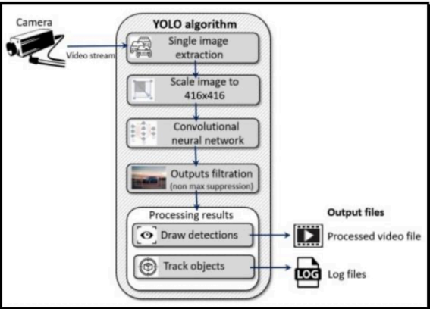

**Fig.1: Architecture diagram of Object Detection**

**RESULTS**

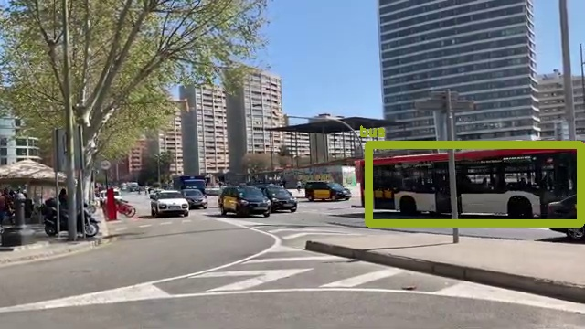 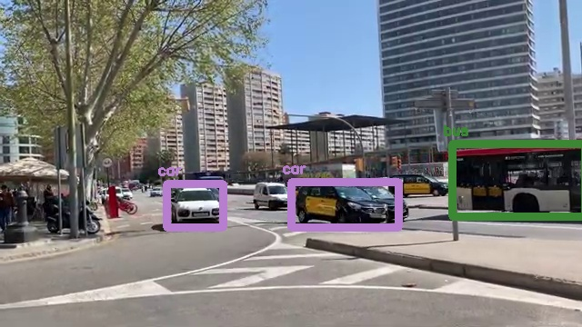

**Fig 2. Location Bus Identification Fig 3. Car Identification**

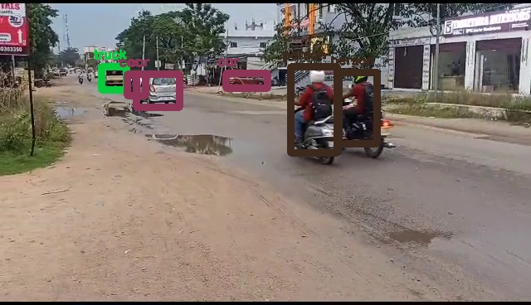

**Fig 4. Motor Cycle identification with Local Video**

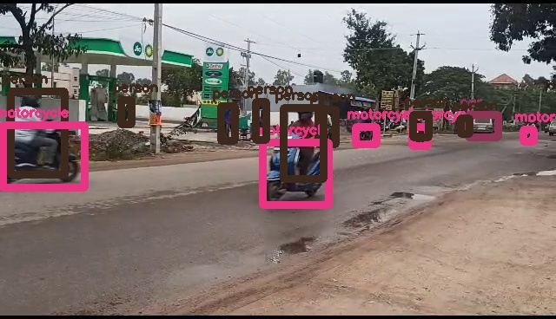

**Fig 5. Motor Cycle identification on Local VIdeo**

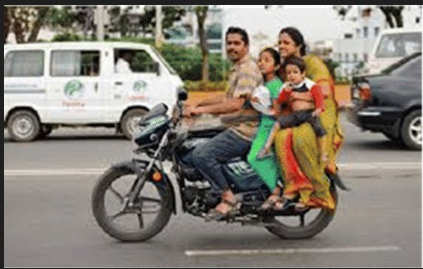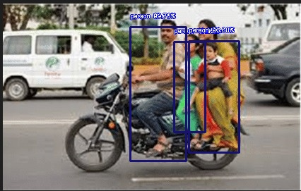

**Fig 6-7. Triple Ride Detection before and after**

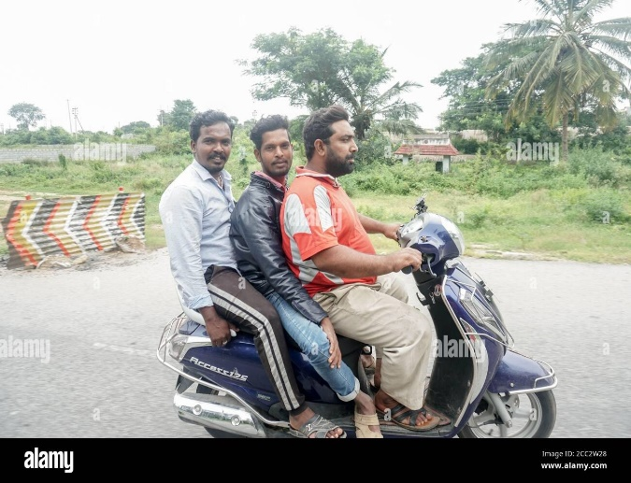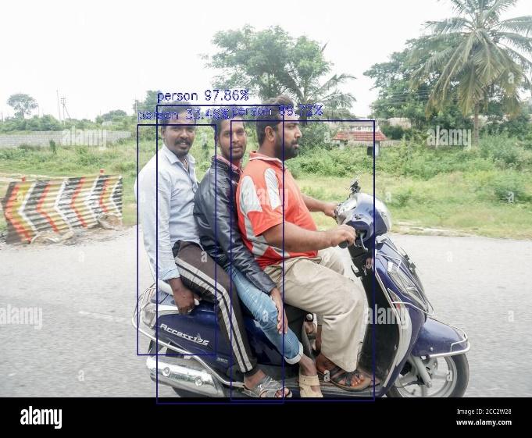

**Fig 8-9. Triple Ride Detection before and after**

**X`**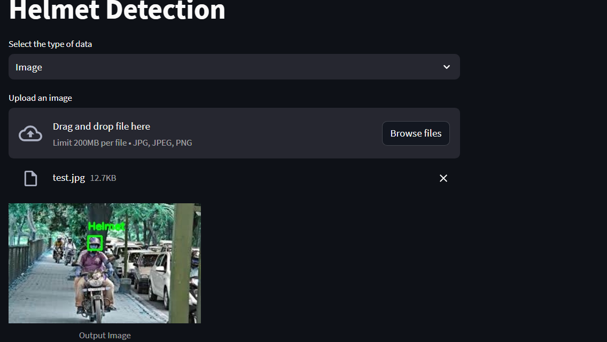

**Fig 10 Helmet detection**

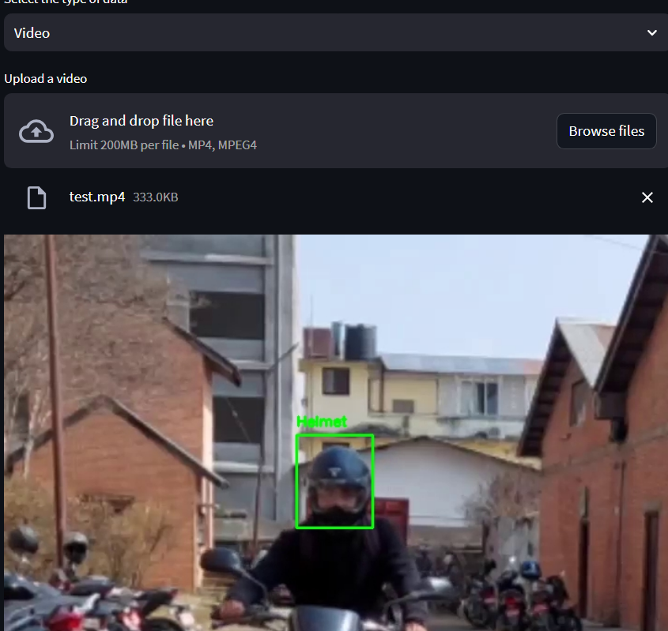

**Fig 11. Video Input-Output Helmet detection**

**CONCLUSION**

A triple riding motorcycle identification is developed where a picture is taken as input and recognizes it as triple ride if it is. Road Object detection program is developed, which takes a video as input and throws output video with identified objects car, motorcycle, bus, person, truck. Successfully implemented YOLOV3 algorithm to detect Road Objects using Python and its required packages effectively.

**FUTURE SCOPE**

It can be improved by integrating Machine learning algorithms and advanced Hardware components like Jetson Nano or Intel One API tools etc in real time.

**REFERENCES**

[1]. [OpenCV DNN Module and Deep Learning (A Definitive guide) (learnopencv.com)](https://learnopencv.com/deep-learning-with-opencvs-dnn-module-a-definitive-guide/)

[2]. [A Gentle Introduction to Object Recognition With Deep Learning - MachineLearningMastery.com](https://machinelearningmastery.com/object-recognition-with-deep-learning/)

[3]. [Official English Documentation for ImageAI! — ImageAI 3.0.2 documentation](https://imageai.readthedocs.io/en/latest/)

[4]. [NumPy](https://numpy.org/)

[5]. [Microsoft Word - Traffic Violation Proctoring System Document.docx (anits.edu.in)](https://ece.anits.edu.in/Project%20Reports%202020-21/Sec-C/C-13.pdf)

[6]. [The Definitive Guide to Object Detection (augmentedstartups.com)](https://www.augmentedstartups.com/blog/the-definitive-guide-to-object-detection-applications-models-and-future-trends)

[7]. Mahaur, B., Singh, N. & Mishra, K.K. Road object detection: a comparative study of deep learning-based algorithms. Multimed Tools Appl 81, 14247–14282 (2022). <https://doi.org/10.1007/s11042-022-12447-5>.

[8]. Song, H., Liang, H., Li, H. et al. Vision-based vehicle detection and counting system using deep learning in highway scenes. Eur. Transp. Res. Rev. 11, 51 (2019). <https://doi.org/10.1186/s12544-019-0390-4>

[9]. Emin Güney, Cuneyt Bayilmis, An Implementation of Real-Time Traffic Signs and Road Objects Detection Based on Mobile GPU Platforms, January 2022IEEE Access PP(99):1-1, DOI:[10.1109/ACCESS.2022.3198954](http://dx.doi.org/10.1109/ACCESS.2022.3198954).

**SOURCE CODE AND CONFIGURATION FILES**

1. Vprg.py
2. Tripleride.pynb
3. Final.py